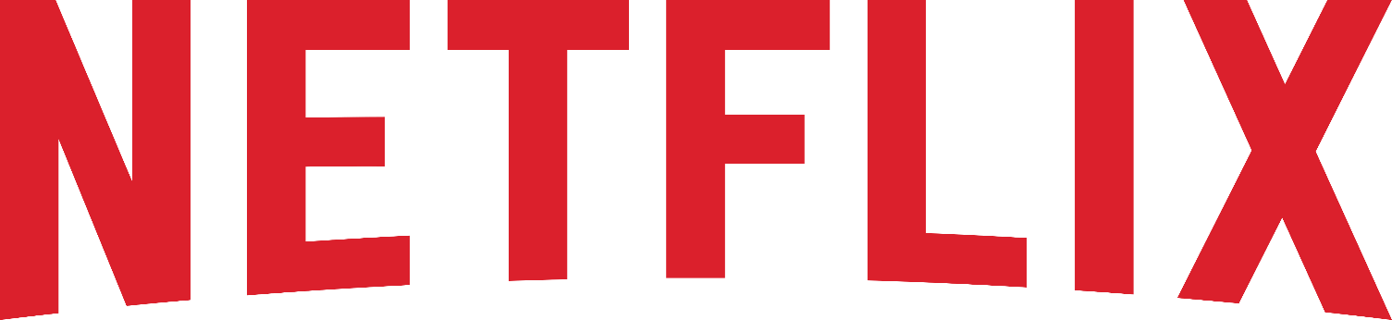

**Product Dissection for Netflix:**

**Company Overview:**

Netflix, founded in 1997 by Reed Hastings and Marc Randolph, is a global streaming platform that has revolutionized the way people consume entertainment content. It offers a vast library of movies, TV shows, documentaries, and original programming. With millions of subscribers worldwide, Netflix has become a leading player in the streaming industry.

User Experience:

Netflix provides a seamless and user-friendly experience for its subscribers. Users can access content on various devices, including smart TVs, smartphones, tablets, and computers. The platform is designed to be intuitive and easy to navigate, with personalized recommendations prominently displayed.

Content Catalog:

Netflix's content catalog is extensive and diverse, spanning various genres and languages. The platform categorizes content into genres, making it easy for users to discover new titles. Netflix also produces its own original content, including acclaimed series like "Stranger Things" and "The Crown."

User Profiles:

Netflix allows multiple user profiles within a single account. Each profile can have its own viewing history, recommendations, and settings. This feature caters to households with multiple users, ensuring a personalized experience for each member.

Recommendation Algorithm:

One of Netflix's standout features is its recommendation algorithm. The platform uses data from users' viewing history, ratings, and interactions to suggest content tailored to individual preferences. This personalized recommendation system plays a crucial role in user engagement and content discovery.

Viewing History:

Netflix keeps track of users' viewing history, allowing them to easily resume watching where they left off. This feature enhances the user experience by enabling seamless content consumption.

Content Streaming:

Netflix employs advanced streaming technology to deliver high-quality content. It adapts to users' internet speeds and device capabilities to ensure smooth playback. The platform offers multiple quality settings to accommodate varying internet connections.

User Interactions:

Users can interact with content by rating, reviewing, and adding titles to their watch list. These interactions help Netflix further refine its recommendations and engage users in the content discovery process.

Payment and Subscription:

Netflix offers different subscription plans with varying levels of access and quality. Users can sign up for monthly subscriptions and make payments through various methods. Managing subscriptions and billing is made straightforward for users.

Content Creation:

Netflix has ventured into content creation with its original series and movies. The platform invests heavily in producing exclusive content, collaborating with renowned filmmakers and actors. Original content is integrated into the overall catalog and promoted to users.

Conclusion:

Netflix's success lies in its ability to provide a user-centric streaming experience with a vast content library, personalized recommendations, and high-quality streaming technology. This research provides the foundation for understanding Netflix's schema design and how it supports its core features and functionalities.

### **Product Dissection and Real-World Problems Solved by Netflix:**

In this step, we'll delve into Netflix's standout features and how they offer innovative solutions to real-world challenges. By identifying key functionalities that resonate with users, we'll unravel how Netflix effectively addresses problems and enhances user experiences.

1. Personalized Content Recommendations:

Real-World Challenge: In a world with an overwhelming amount of content, users often struggle to find movies and shows that align with their preferences.

Netflix Solution: Netflix employs a powerful recommendation algorithm that analyzes users' viewing history, ratings, and interactions. This technology provides personalized content recommendations, making it easier for users to discover new titles that match their interests. By addressing the challenge of content discovery, Netflix enhances the user experience and keeps subscribers engaged.

2. User Profiles and Multiple Viewing Histories:

Real-World Challenge: In households with multiple viewers, it can be challenging to maintain individualized viewing histories and recommendations.

Netflix Solution: Netflix allows multiple user profiles within a single account, each with its own viewing history and recommendations. This feature caters to households with diverse tastes, ensuring that family members have a personalized experience. By solving the problem of shared viewing experiences, Netflix promotes harmony among users and encourages broader adoption.

3. Seamless Content Playback:

Real-World Challenge: Varying internet speeds and device capabilities can lead to buffering and interrupted content playback.

Netflix Solution: Netflix utilizes adaptive streaming technology that adjusts the quality of content based on users' internet connections and device capabilities. This ensures smooth playback and minimizes buffering issues. By addressing the challenge of content delivery, Netflix enhances the overall viewing experience, even in regions with inconsistent internet connectivity.

4. Original Content Production:

Real-World Challenge: Traditional content providers may limit the availability of original and diverse content.

Netflix Solution: Netflix has invested significantly in producing original series and movies. By collaborating with renowned filmmakers and actors, the platform offers a wide range of exclusive content. This solution addresses the challenge of content diversity and provides subscribers with unique and compelling entertainment options.

5. User Engagement through Interactions:

Real-World Challenge: Users often seek ways to engage more deeply with content beyond passive viewing.

Netflix Solution: Netflix encourages user interactions by allowing users to rate, review, and add titles to their watch list. These interactions not only provide feedback to the recommendation algorithm but also engage users in content discovery and discussion. By addressing the challenge of user engagement, Netflix fosters a sense of community among subscribers.

6. Cross-Device Accessibility:

Real-World Challenge: Users want the flexibility to access content on various devices seamlessly.

Netflix Solution: Netflix offers cross-device compatibility, allowing users to switch between devices while maintaining their viewing progress. This feature addresses the challenge of device versatility, enabling users to enjoy content on their terms, whether at home or on the go.

7. Billing and Subscription Management:

Real-World Challenge: Managing subscription plans and payments can be cumbersome.

Netflix Solution: Netflix simplifies billing and subscription management, offering different subscription plans and flexible payment options. Users can easily upgrade or cancel subscriptions, providing transparency and control. This solution streamlines the subscription process, making it user-friendly and convenient.

**Case Study on Real-World Problems and Netflix's Innovative Solutions**

In this pivotal step, we'll expand on the real-world challenges identified in Step 3 through a comprehensive case study. We'll delve into specific instances where Netflix users encountered difficulties and showcase how Netflix's unique features provided effective solutions. This case study will help us dissect the approach taken by Netflix to overcome these challenges and gain a deeper understanding of its user-centric design philosophy.

Case Study 1: Personalized Content Recommendations

Challenge: Rahul, a Netflix subscriber, often found himself spending more time searching for content than actually watching it. He felt overwhelmed by the vast content library.

Netflix Solution: Netflix's recommendation algorithm analyzed Rahul’s viewing history and preferences. It started suggesting movies and TV shows based on his past choices, leading to a more tailored content discovery experience. As a result, Rahul spent less time searching and more time enjoying content that resonated with his interests.

Case Study 2: User Profiles and Multiple Viewing Histories

Challenge: The Gupta family shares a single Netflix account, but each member has different tastes in entertainment. They found it frustrating when their viewing histories and recommendations got mixed up.

Netflix Solution: Netflix allowed each family member to create their own user profile within the same account. This separated their viewing histories and recommendations, ensuring that everyone had a personalized experience. Now, the Gupta family enjoys harmonious co-viewing without compromising individual preferences.

Case Study 3: Seamless Content Playback

Challenge: Manisha, a Netflix subscriber living in an area with inconsistent internet connectivity, often experienced buffering while streaming her favorite shows.

Netflix Solution: Netflix's adaptive streaming technology recognized Manisha's varying internet speeds. It automatically adjusted the content quality to ensure smooth playback, even in areas with limited bandwidth. Manisha could now enjoy uninterrupted streaming without the frustration of buffering.

Case Study 4: Original Content Production

Challenge: Kartik, a long-time Netflix user, sought fresh and engaging content beyond what traditional studios offered.

Netflix Solution: Netflix's commitment to producing original series and movies met Kartik's desire for unique content. The platform's collaborations with talented creators brought fresh stories and diverse perspectives to its catalog. Now, Kartik had access to a rich library of exclusive content that traditional providers couldn't match.

Case Study 5: User Engagement through Interactions

Challenge: Natasha, an avid Netflix user, wanted to share her thoughts and recommendations with friends and fellow subscribers.

Netflix Solution: Netflix allowed Natasha to rate, review, and add titles to her watch list. These interactions not only enhanced her own content discovery but also facilitated discussions with friends and fellow viewers. Natasha felt more connected to the Netflix community, fostering a sense of shared enthusiasm for entertainment.

Case Study 6: Cross-Device Accessibility

Challenge: Ashish, a frequent traveler, wanted the flexibility to continue watching his favorite shows seamlessly across different devices.

Netflix Solution: Netflix's cross-device compatibility enabled Ashish to pick up where he left off on his smartphone during a layover or resume watching on his smart TV when he returned home. The transition between devices was seamless, aligning with Ashish's dynamic lifestyle.

Case Study 7: Billing and Subscription Management

Challenge: Kavita, a Netflix subscriber, needed an easy way to adjust her subscription plan as her viewing habits changed.

Netflix Solution: Netflix's user-friendly subscription management allowed Kavita to upgrade or downgrade her plan with a few clicks. Billing was straightforward, and she had the flexibility to adjust her subscription to suit her needs without any hassle.

These case studies illustrate how Netflix's innovative solutions effectively address real-world challenges faced by its users. By dissecting these examples, we gain a deeper appreciation for Netflix's commitment to enhancing the user experience.

**Schema Design Based on Top Features:**

Based on the features and functionalities of Netflix, we'll craft a schema design that reflects how Netflix organizes and utilizes its data. This schema will help us understand how Netflix's data architecture drives the platform's effectiveness.

Entities and Attributes:

**User Entity:**

* **UserID** (Primary Key)
* **Username**
* **Email**
* **Password** (hashed and salted)
* **Subscription_Plan** (e.g., Basic, Standard, Premium)
* **Payment_Information**
* **Registration_Date**

**Profile Entity:**

* **ProfileID** (Primary Key)
* **UserID** (Foreign Key referencing User Entity)
* **Profile_Name** (e.g., "John's Profile," "Family Profile")
* **Viewing_History** (linked to Content Entity)
* **Recommendations** (generated by Netflix's algorithm, linked to Content Entity)
* **User_Interactions** (e.g., ratings, reviews, watchlist)

**Content Entity:**

* **ContentID** (Primary Key)
* **Title** (movie or TV show name)
* **Description**
* **Genres** (tags/categories)
* **Release_Year**
* **Cast_and_Crew**
* **Duration**
* **Viewer_Ratings**

**Interaction Entity:**

* **InteractionID** (Primary Key)
* **UserID** (Foreign Key referencing User Entity)
* **ContentID** (Foreign Key referencing Content Entity)
* **Interaction_Type** (e.g., watched, rated, reviewed, added to watchlist)
* **Interaction_Date**

**Device Entity:**

* **DeviceID** (Primary Key)
* **UserID** (Foreign Key referencing User Entity)
* **Device_Type** (e.g., smartphone, smart TV, laptop)
* **Device_Name** (e.g., "John's Phone," "Living Room TV")
* **Device_Preferences** (e.g., streaming quality settings)

**Subscription Entity:**

* **SubscriptionID** (Primary Key)
* **UserID** (Foreign Key referencing User Entity)
* **Plan_Type** (e.g., Basic, Standard, Premium)
* **Subscription_Start**
* **Billing_Info**
* **Payment_History**

**Relationships:**

* **Users subscribe to Subscription Plans (1:M relationship):**

*Each user can have multiple subscriptions based on different plans and billing cycles. Each subscription is associated with one user.*

* **Users can create multiple Profiles within their accounts (1:M relationship):**

*Each user can have multiple profiles within their Netflix account.*

*Each profile is associated with one user.*

* **Users interact with Content through various actions (watching, rating, reviewing, adding to watch list) (M:M relationship) :**

*Users can interact with multiple content items, such as movies and TV shows, by watching, rating, and reviewing them.*

*Content can be interacted with by multiple users who watch, rate, and review it.*

* **Devices are associated with Users and store device-specific preferences (1:M relationship):**

*Each user can use multiple devices to access their Netflix account.*

*Each device is used by one user.*

**E-R Diagram:**

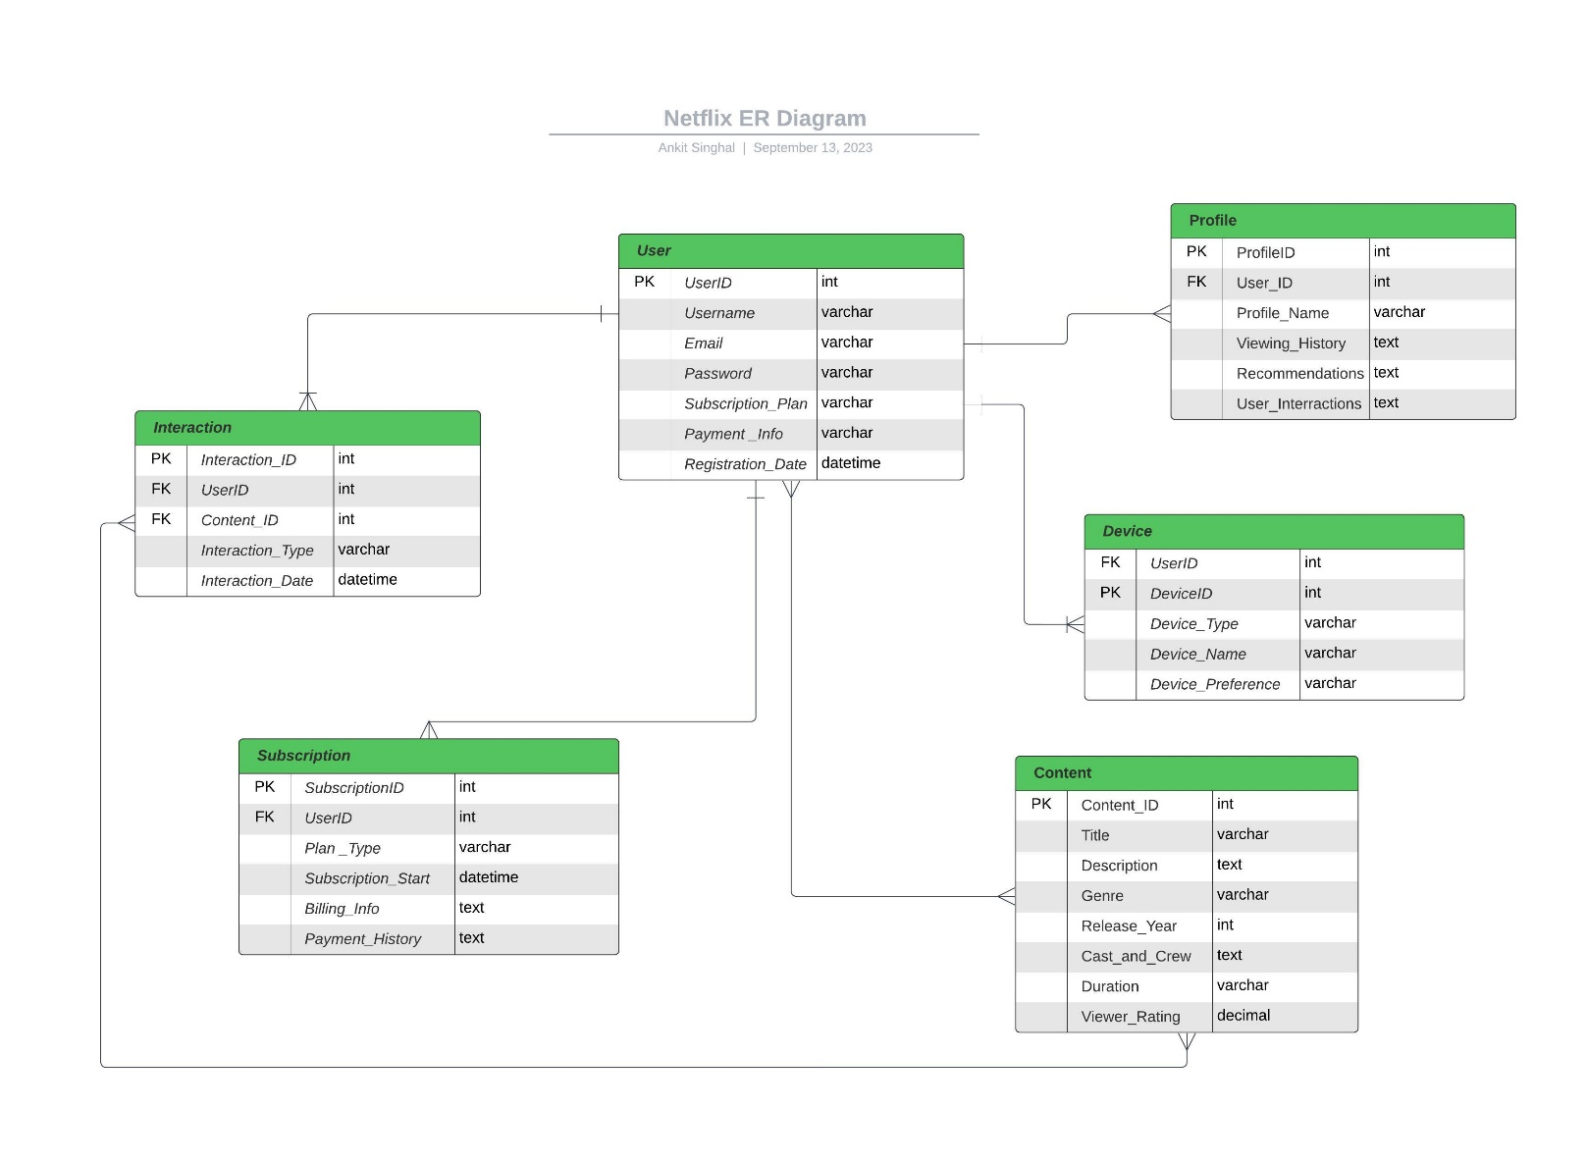

**Conclusion:**

Netflix, the streaming giant, relies on a smart schema design to make your viewing experience smooth. This design helps Netflix tackle real-life issues and make your time enjoyable.

Key parts of this schema include:

User: Your Netflix account info.

Profile: Separate spaces for family members.

Device: Your choice of screens.

Subscription: The plan you pick.

Content: All the movies and shows.

Genre: Categories like action or drama.

Interaction: Your likes, reviews, and watches.

Netflix's design is smart. It understands your needs and keeps things simple, making it the streaming king it is today.

Relational Database Capstone Project prepared by:   
  
- Ankit Singhal

(Data Science Trainee at Almabetter)

Technical Document Link:

https://docs.google.com/document/d/1D8UHI38hM9h0Z2doGGksS54L_Oy3t6R3/edit?usp=sharing&ouid=111555609708337608226&rtpof=true&sd=true

Video Presentation Link: https://drive.google.com/file/d/1C6uV4_ganJGMXKjZh64TdhIue_JLL6QM/view?usp=sharing

GitHub Link: